MONITORING VISIT TO MINDANAO FARMERS
March 4-7, 2015
=====================================================================

Mr. Donard Angeles- PREDA Pro Far Trade Producer's Development Officer together with Mr. Francis Bermido- PREDA’s Executive Director conducted monitoring visit to Davao mango growers: Among the activities conducted are the following:

- ORIENTATION ON CHILDREN AND WOMEN’S RIGHTS – The farmers gained knowledge about the Republic Act 7610 ( Children’s Rights), RA 9208 (Human Trafficking), RA 9344 and RA 9262 ( Violence against women and their Children). Afterwards, Preda Komiks was distributed to the farmers. Below are the list of participants per farmers group:

FARMERS GROUP | DATE OF MEETING | NO. OF PARTICIPANTS
Banas 1 Womens Association | March 4, 2015 | 16
United Womens farmers Organ ization | March 5, 2015 | 16
Bayabas Farmers Group | March 5, 2015 | 11
Kapalong-Asuncion Farmers Group | March 6, 2015 | 18
Tibal-og farmers Group | March 6, 2015 | 5
Panabo Mango Farmers | March 7, 2015 | 23
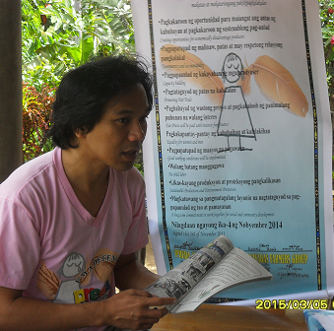
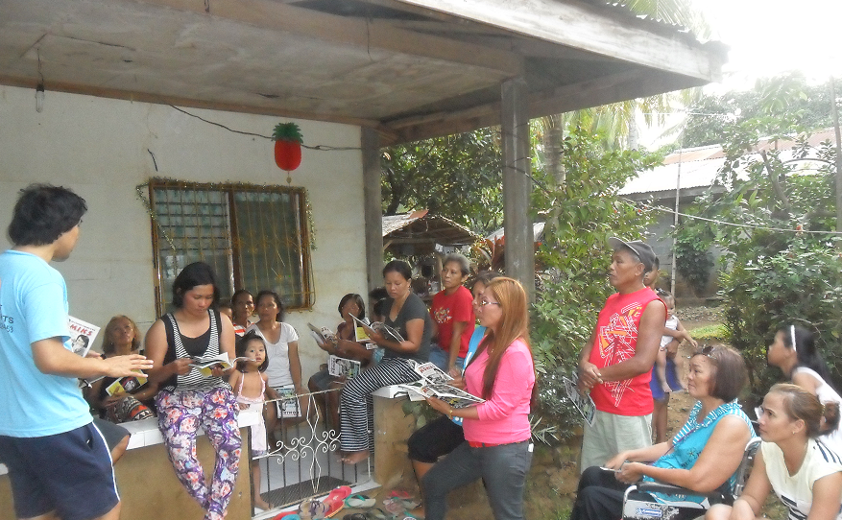

PREDA Executive Director explains about the Children and Womens rights using PREDA Komiks.
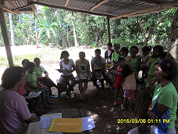

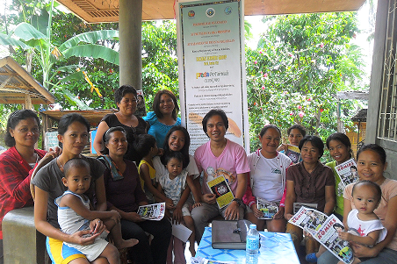

- Monitoring of Mango Deliveries- Upon checking the yellow and green card, a total of 77,683.0 kilos was delivered by 28 farmers coming from 4 groups (covering the period November 8-March 6, 2015). Details are the following:

GROUP | NO. OF FARMERS | NO. OF KILOS
BAIWA | 3 | 5,268.0
United Womens farmers Organ ization | 4 | 3,876.5
PANABO FARMERS | 9 | 30,018.0
KAPALONG | 12 | 38,520.0
TOTAL | 28 | 77,683.0
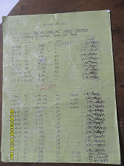
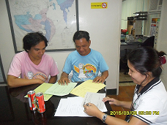
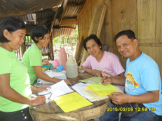

PREDA Executive Director observes the checking of mango deliveries conducted by the PROFAITRADE producers Development Officer.

- awarding of Fair Trade Premium – a total of 31 mango farmers coming from 4 communities received a total of Php 286,024.00. This was their bonus on the mango delivered for the preiod of May 25-November 7, 2014..

GROUP | NO. OF FARMERS | FAIR TRADE PREMIUM
BAIWA | 16 | 132,480.00
BAYABAS GRP | 1 | 17,220.00
PANABO FARMERS | 9 | 93,480.00
KAPALONG | 5 | 47,520.00
TOTAL | 31 | Php 286,024.00
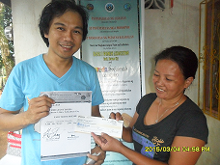
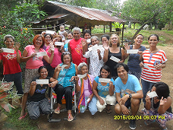

HAPPY FARMERS RECEIVED THEIR FAIR TRADE PREMIUM
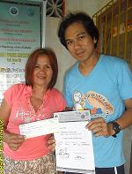
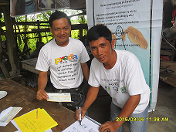
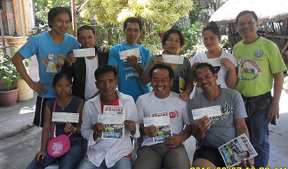

- Meeting and visit to Profood Davao Plant – Mr. Francis Bermido – PREDA ExecutiveDirector visited and observed the processing plant as per the flow of the fruit processing.

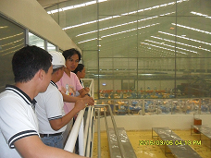
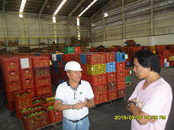
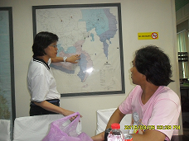

Peeling & slicing section
Fresh mango receiving section
Ms. Jean Uy-Young of Profood Davao gave orientation about the partnership and mango processing

Fresh mango receiving section

- Preda Profairtrade agriculturist & Executive Director conducted farm monitoring .
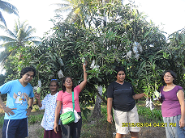
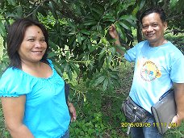
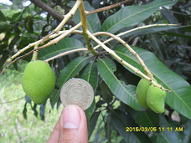

Mango Fruit compared to a 5 peso coin for sizing
Bayabas Group
Banas 1 Womens Association

- Educational Assistance – The Producers Dev’t Officer explained the “ One Farmer, One Child Policy”- Preda ProFairTrade will provide educational assistance in form of school supplies, one child per farmer member. As per college scholarship, Mr. Francis Bermido-Executive Director informed them that PredaProFairTrade will shoulder the tuition fee & monthly school allowance of the graduating child of the farmer member. Same as with the vocational courses. Executive Director reiterated that college educatinal assistance is only valid for students enrolled in public/state colleges and universities.

Prepared by:

DONARDO ANGELES
Producers Development Officer

Noted by:

AMABELLE FACTURANAN FRANCIS BERMIDO FR. SHAY CULLEN
PFT-Project Coordinator Executive Director General Manager

